Nate Abott, Vir Patel, Sam Mathews, Chris Kalra, Tyler Ryan
Block E - 2021 - Fall Semester

Project Lake Kilroy Buoy 100
Description and Goals 100
Journal 101
Project Summation - Success / Failure Report 111
Drawing Index 112
Code Documentation : Thingspeak Buoy 113
Code Documentation : MAC address scraping 117
Planning and Strategy 118
Fabrication Standards 119
Journal Entry Template 120

Project Lake Kilroy Buoy

Description and Goals
Create a system that collects data from Lake Kilroy.

Journal
Date: | 10/29/21
Agenda/Goals: | - Meet with Ecology class and find what they need as a sensor from our class
Actions: | - Met during lunch with Ecology class, ate pizza while they presented what the sensor they wanted should do. We recorded notes: https://docs.google.com/document/d/1e5_YdGMpoTyvx33TJYa9ev_MXNKavHYK-FqX-d68io0/edit?usp=sharing
Impact: | - We discovered that they wanted to test how well fish can thrive in Lake Kilroy (see “recorded notes”)
Next Steps | - Find sensors needed for sensor system to collect data  - Order sensors  - Diagram how we will record data in the middle of the lake
Testing | - N/A

Date: | 11/1/21 - 11/9/21 （6 Classes)
Agenda/Goals: | - Brainstorm structure of buoy system that will hold up sensors  - Brainstorm needed sensors  - Research and order sensors and parts for buoy
Actions: | - Created structural design for buoy system and how sensors will be attached  - Found how we will sensor everything needed  - Researched and listed all the parts we need - shown below:  https://docs.google.com/spreadsheets/d/1vwCJRmhRVAE8fZO3DM2VAyYhDCar_1JU14M18UelrP4/edit?usp=sharing  https://drive.google.com/drive/folders/1JIwyiUCwQh89PRqp9eMPjChaZu81qOKp?usp=sharing  - Items we need  - Multiply all values by 2  - Pool Noodles  - Formufit 1-1/2 in. Furniture Grade PVC 5-Way Cross in White (4-Pack) - 1  - Charlotte Pipe 1-1/2 in. PVC Schedule 40 S x S x S x S Cross - 1  - Charlotte Pipe 1-1/2 in. PVC Schedule. 40 45-Degree S x S Elbow Fitting - 16  - JM EAGLE 1/2 in. x 10 ft. PVC Schedule 40 Plain-End Pipe - 2  - 1-1/2 in. Furniture Grade PVC 4-Way Tee in White (4-Pack) - 1
Impact: | We are have designed our entire system and are waiting to test it to see if the system works
Next Steps | Find depth of the lake and order parts
Testing | N/A

Pictures:
Picture of buoy diagrams:
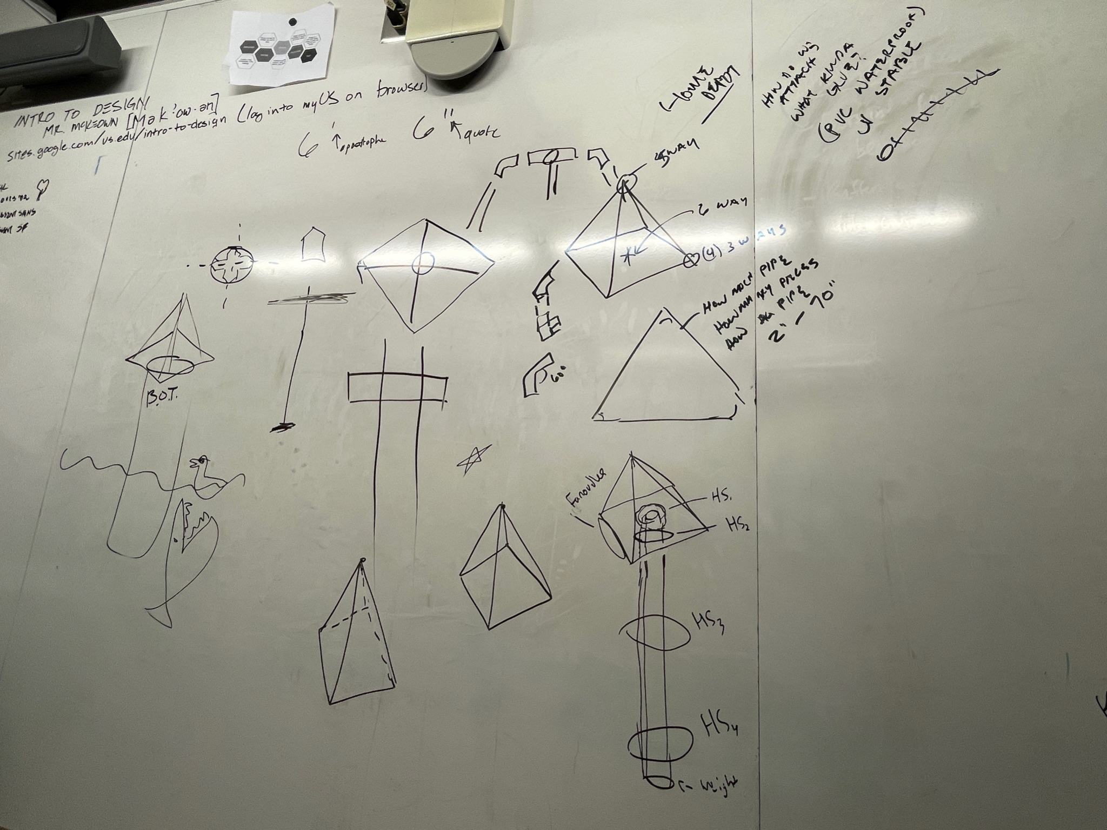
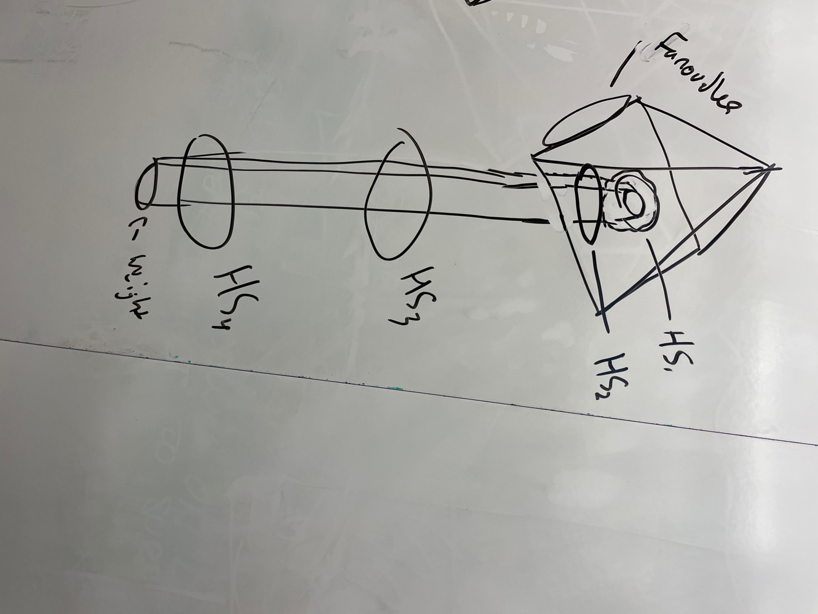

Date: | 11/10/21
Agenda/Goals: | Measure depth of the lake
Actions: | We went out in a canoe and dropped a weight attached to a rope at different places. We then tied a knot where the rope met the water and recorded the gps location.
Impact: | We have data points and locations for different depths
Next Steps | We will measure the rope to find the different depths
Testing | N/A

Date: | 11/12/21
Agenda/Goals: | - We will measure the different depths to find the deepest depth  - We will give Mr. McKeown a list of needed parts for our system
Actions: | - We measured where the different knots were and recorded the depths relative to their gps location. We also gave Mr. McKeown a list of needed parts and sensors (listed in the previous engineering journal.
Impact: | - We know the deepest depth and Mr. McKeown knows the parts we need.
Next Steps | - Purchase the sensors and parts
Testing | N/A

Pictures:
Picture of notes for the lengths of the rope at various locations at Lake Kilroy:
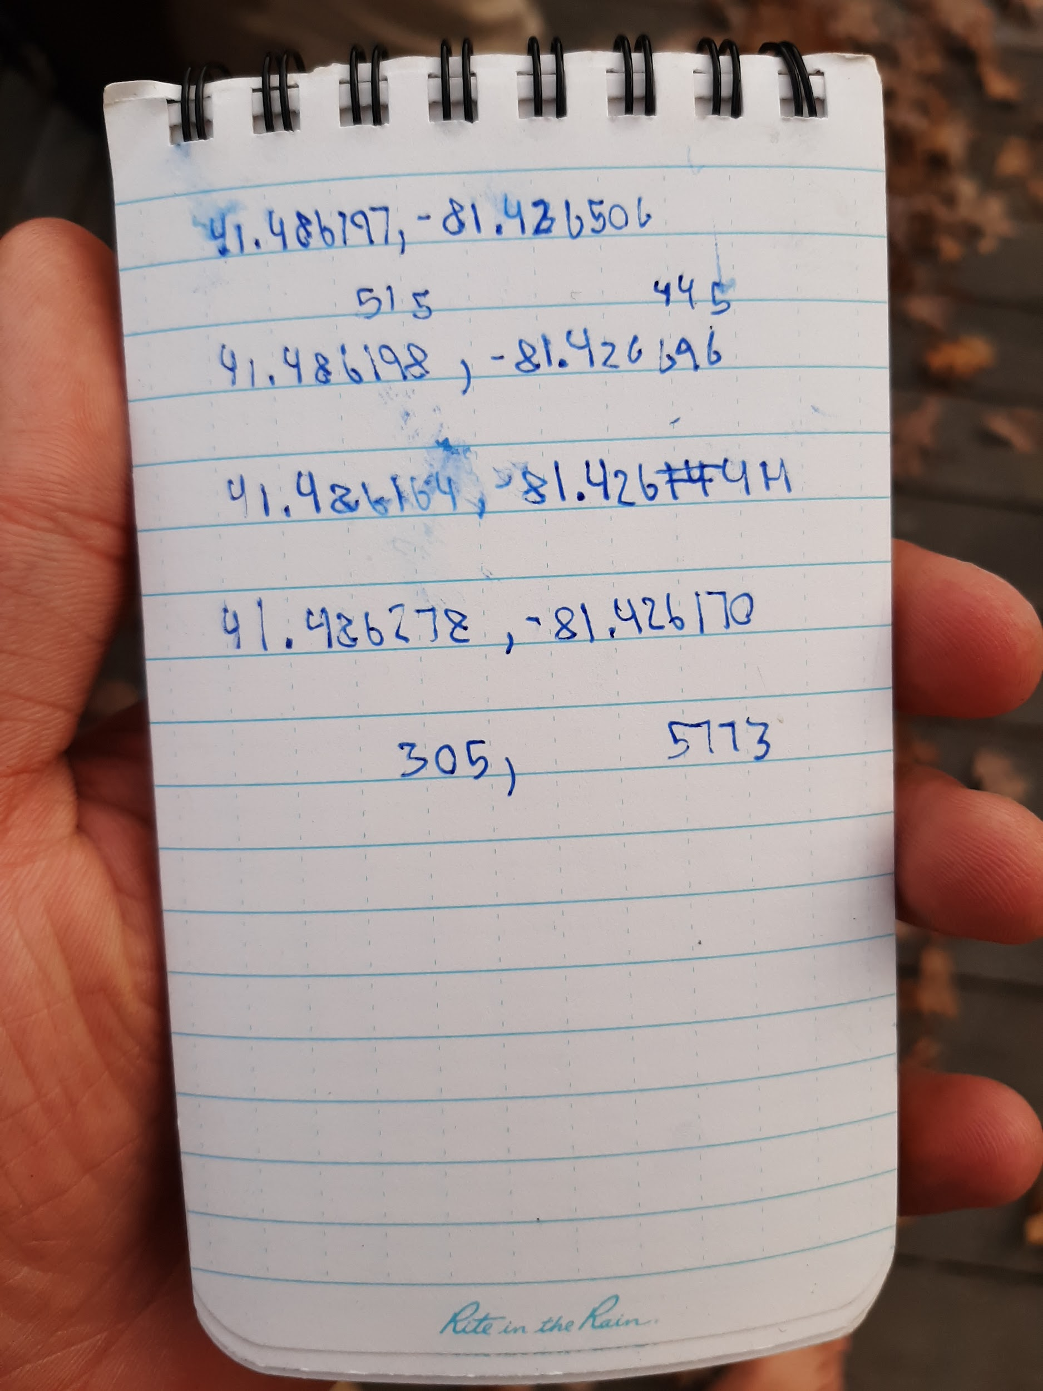

Date: | 11/15/21
Agenda/Goals: | - Come up with a solidified plan for the buoy and how to attach the sensor unit and the solar panel
Actions: | - A design with a solidified plan for the buoy was created  - There is a rough drawing on Fusion 360 although the technology had its limitations (pictures below)
Impact: | - The construction phase of the project can be started
Next Steps | - Build the buoy
Testing | N/A

Date: | 11/29/21
Agenda/Goals: | Construction of buoye  Working on code for wind speed and direction
Actions: | Constructing the buoye with the full 40 inch long PVC
Impact: | The buoye in the end was way too big so I had to rebuild and cut it so that it fits. The 5 holed connectors were too big so we had to sand down each hole to fit the 45° connector piece. We started to build the smaller buoye
Next Steps | Finish smaller buoye and start code
Testing
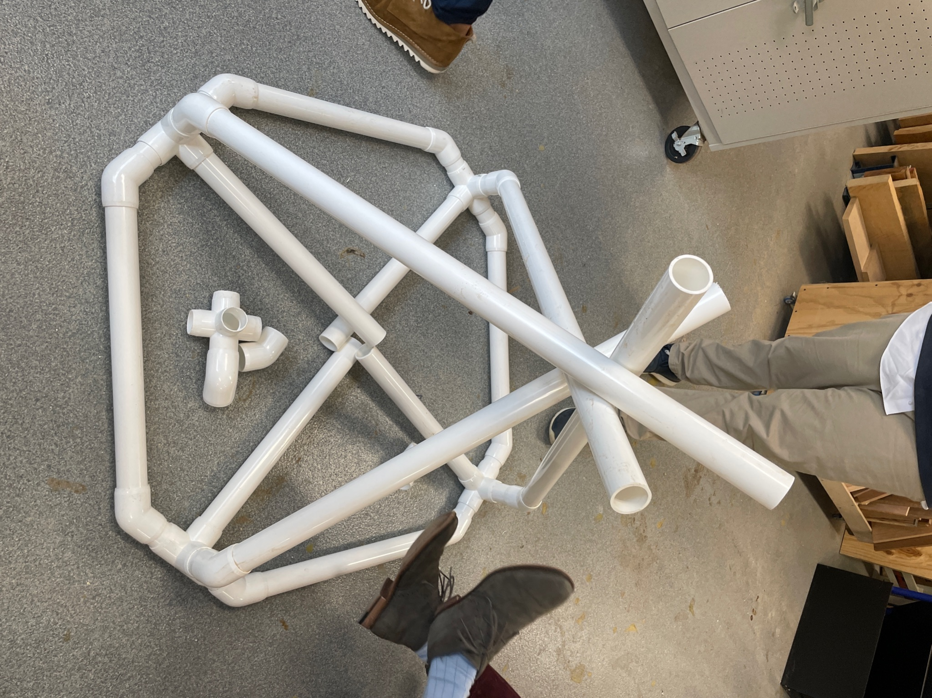
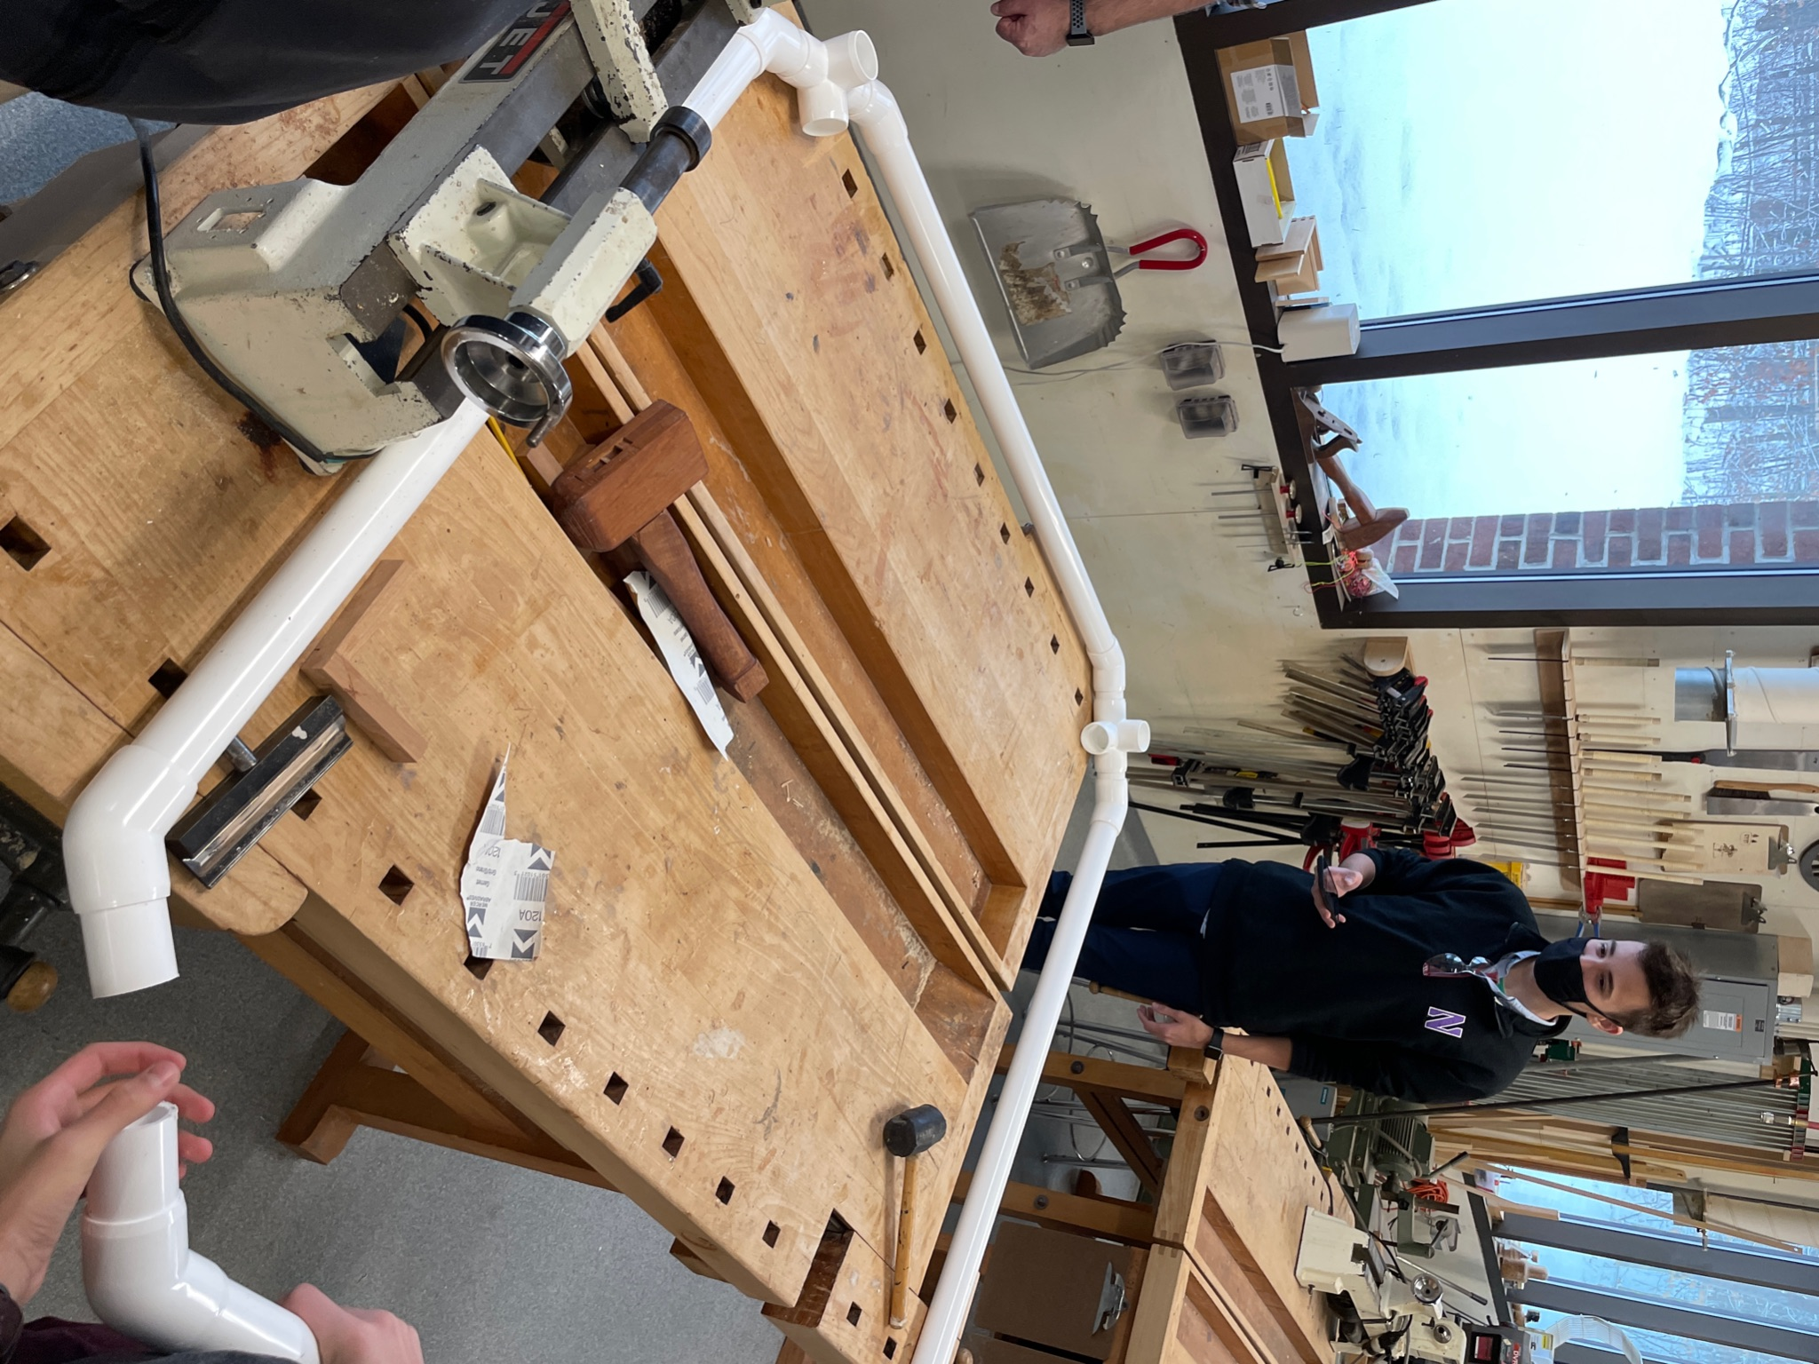
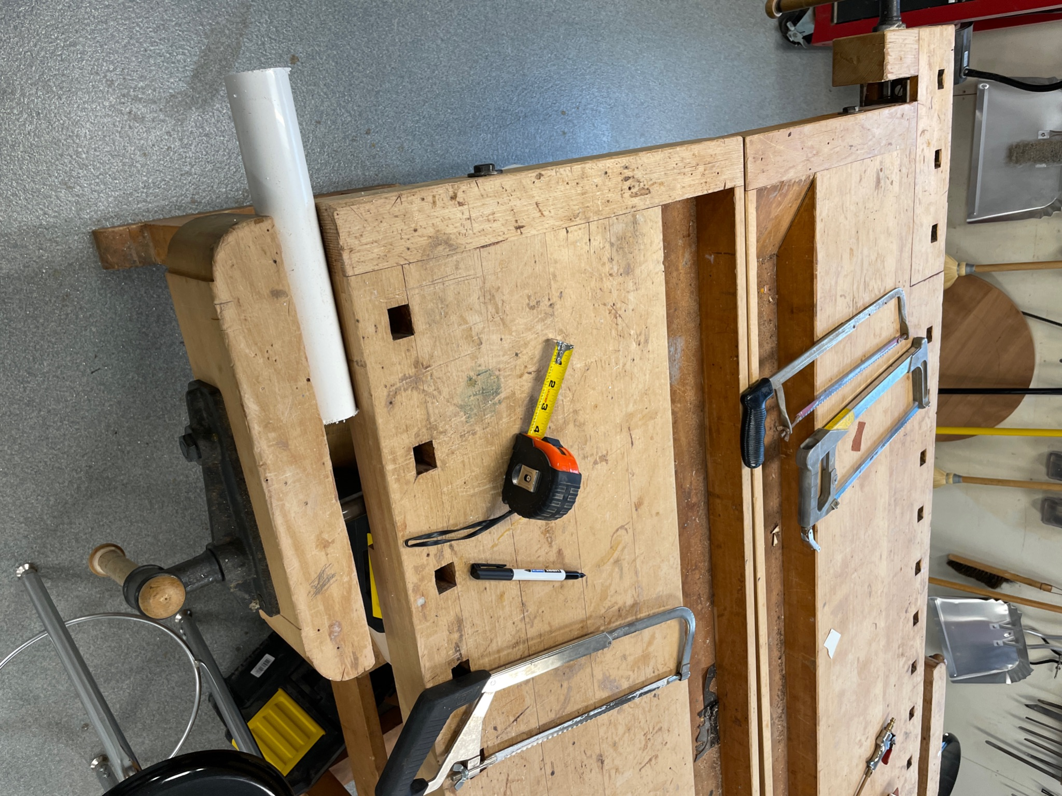

Date: | 11/30/21
Agenda/Goals: | Finish smaller buoye and start code
Actions: | Finish smaller buoye and measure at 18 and 20 inches
Impact: | Finished buoye with not many problems
Next Steps | Attach sensors to bouye and code
Testing

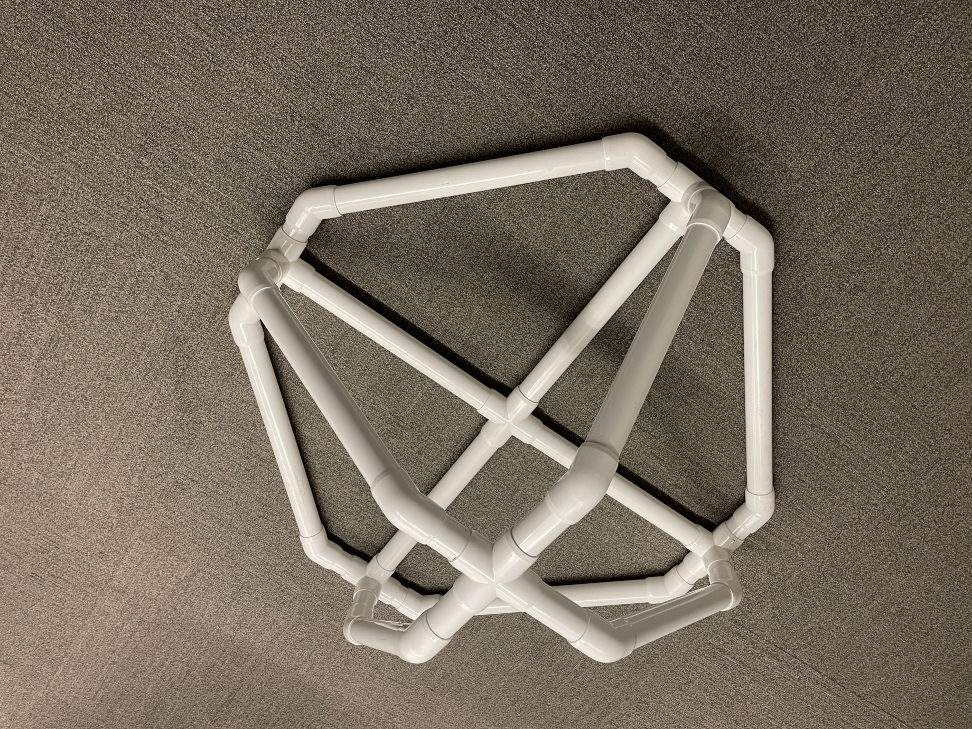
Date: | 12/1/21
Agenda/Goals: | Attach sensors to bouye and code
Actions: | Attach sensors to bouye and thinking about anchor placement
Impact: | Sensor box attach to buoye
Next Steps | Do Code and think about anchor
Testing
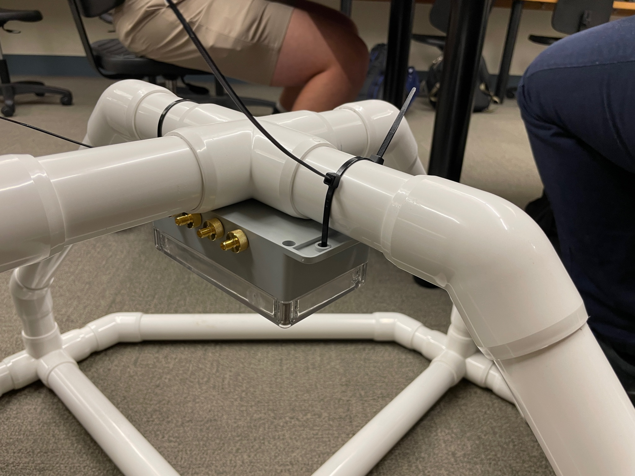
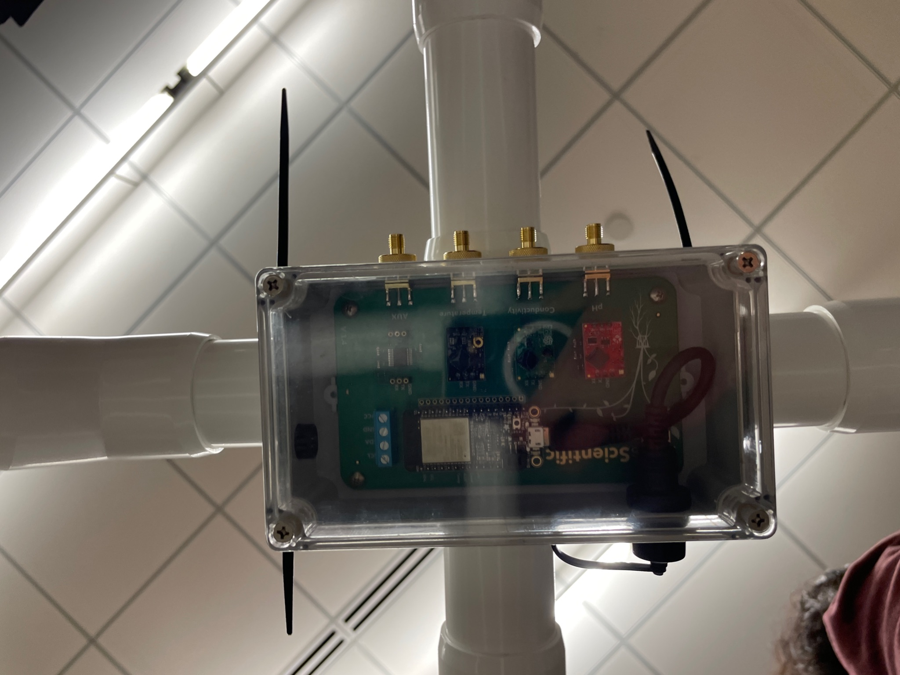

Date: | 12/2/21
Agenda/Goals: | McKeown : Buoy Hardware connect to Thingspeak  - Prep code for Buoy Sensor (code copied to documentation section)  - ThingSpeak Account Created  - Downloaded: Exo_I2c_lib-master library for Thingspeak communication (see google drive)
Actions: | Finding code
Impact: | Got code
Next Steps | Get IP address from buoy sensor to forward to IT for firewall port.
Testing

Date: | 12/7/21
Agenda/Goals: | McKeown : Use MACaddress code to scrape MAC address to get open firewall port
Actions: | Created MAC Sketch for ESP32 chipset Adafruit Feather  See code section for MAC sketch
Impact: | Got the onboard MAC Address: 7C:87:CE:F6:FF:34
Next Steps | Send MAC addy to IT to get clear to firewall for uploading, may use US_Guest network if available to keep standard firewall clear
Testing

Date: | 1/13/2022
Agenda/Goals: | Make a detailed plan to go forward with the project.
Actions: | Completed a plan and buying list  Completed plan: https://docs.google.com/document/d/10aLCrGaqOyH0xLmI2TtPRLGvoSViOB1vq-y5qCIVu-w/edit?usp=sharing  Buying list:  https://docs.google.com/document/d/1FEZtSAEFyEdmGIhpmtEqXAvg65xLSFHOyY5ZAnIC7zs/edit?usp=sharing
Impact: | Formulated a plan to go forward with for this semester.
Next Steps | Buy pool noodles and pvc sleeve
Testing | NA

Project Summation - Success / Failure Report
This section begins your final description of your project in its final state as tested.

Here you will document the necessary steps to replicate your project. Include step by step instructions for fabrication, assembly, coding, and testing.

Drawing Index

Code Documentation : Thingspeak Buoy

//This code is for the Atlas Scientific wifi hydroponics kit with dissolved oxygen that uses the Adafruit huzzah32 as its computer.

#include <iot_cmd.h>
#include <WiFi.h> //include wifi library
#include "ThingSpeak.h" //include thingspeak library
#include <sequencer4.h> //imports a 4 function sequencer
#include <sequencer1.h> //imports a 1 function sequencer
#include <Ezo_i2c_util.h> //brings in common print statements
#include <Ezo_i2c.h> //include the EZO I2C library from https://github.com/Atlas-Scientific/Ezo_I2c_lib
#include <Wire.h> //include arduinos i2c library

WiFiClient client; //declare that this device connects to a Wi-Fi network,create a connection to a specified internet IP address

//----------------Fill in your Wi-Fi / ThingSpeak Credentials-------
const String ssid = "US_Guest"; //The name of the Wi-Fi network you are connecting to
const String pass = ""; //Your WiFi network password
const long myChannelNumber = 1594313; //Your Thingspeak channel number
const char * myWriteAPIKey = "QLHL1BEMCMMCFXHO"; //Your ThingSpeak Write API Key
//------------------------------------------------------------------

Ezo_board PH = Ezo_board(99, "PH"); //create a PH circuit object, who's address is 99 and name is "PH"
Ezo_board EC = Ezo_board(100, "EC"); //create an EC circuit object who's address is 100 and name is "EC"
Ezo_board DO = Ezo_board(97, "DO"); //create an DO circuit object who's address is 97 and name is "DO"
Ezo_board RTD = Ezo_board(102, "RTD"); //create an RTD circuit object who's address is 102 and name is "RTD"
Ezo_board PMP = Ezo_board(103, "PMP"); //create an PMP circuit object who's address is 103 and name is "PMP"

Ezo_board device_list[] = { //an array of boards used for sending commands to all or specific boards
PH,
EC,
RTD,
DO,
PMP
};

Ezo_board* default_board = &device_list[0]; //used to store the board were talking to

//gets the length of the array automatically so we dont have to change the number every time we add new boards
const uint8_t device_list_len = sizeof(device_list) / sizeof(device_list[0]);

//enable pins for each circuit
const int EN_PH = 13;
const int EN_EC = 12;
const int EN_RTD = 33;
const int EN_AUX = 27;

const unsigned long reading_delay = 1000; //how long we wait to receive a response, in milliseconds
const unsigned long thingspeak_delay = 15000; //how long we wait to send values to thingspeak, in milliseconds

unsigned int poll_delay = 2000 - reading_delay * 2 - 300; //how long to wait between polls after accounting for the times it takes to send readings

//parameters for setting the pump output
#define PUMP_BOARD PMP //the pump that will do the output (if theres more than one)
#define PUMP_DOSE -0.5 //the dose that the pump will dispense in milliliters
#define EZO_BOARD EC //the circuit that will be the target of comparison
#define IS_GREATER_THAN true //true means the circuit's reading has to be greater than the comparison value, false mean it has to be less than
#define COMPARISON_VALUE 1000 //the threshold above or below which the pump is activated

float k_val = 0; //holds the k value for determining what to print in the help menu

bool polling = true; //variable to determine whether or not were polling the circuits
bool send_to_thingspeak = true; //variable to determine whether or not were sending data to thingspeak

bool wifi_isconnected() { //function to check if wifi is connected
return (WiFi.status() == WL_CONNECTED);
}

void reconnect_wifi() { //function to reconnect wifi if its not connected
if (!wifi_isconnected()) {
WiFi.begin(ssid.c_str(), pass.c_str());
Serial.println("connecting to wifi");
}
}

void thingspeak_send() {
if (send_to_thingspeak == true) { //if we're datalogging
if (wifi_isconnected()) {
int return_code = ThingSpeak.writeFields(myChannelNumber, myWriteAPIKey);
if (return_code == 200) { //code for successful transmission
Serial.println("sent to thingspeak");
} else {
Serial.println("couldnt send to thingspeak");
}
}
}
}

void step1(); //forward declarations of functions to use them in the sequencer before defining them
void step2();
void step3();
void step4();
Sequencer4 Seq(&step1, reading_delay, //calls the steps in sequence with time in between them
&step2, 300,
&step3, reading_delay,
&step4, poll_delay);

Sequencer1 Wifi_Seq(&reconnect_wifi, 10000); //calls the wifi reconnect function every 10 seconds

Sequencer1 Thingspeak_seq(&thingspeak_send, thingspeak_delay); //sends data to thingspeak with the time determined by thingspeak delay

void setup() {

pinMode(EN_PH, OUTPUT); //set enable pins as outputs
pinMode(EN_EC, OUTPUT);
pinMode(EN_RTD, OUTPUT);
pinMode(EN_AUX, OUTPUT);
digitalWrite(EN_PH, LOW); //set enable pins to enable the circuits
digitalWrite(EN_EC, LOW);
digitalWrite(EN_RTD, HIGH);
digitalWrite(EN_AUX, LOW);

Wire.begin(); //start the I2C
Serial.begin(9600); //start the serial communication to the computer

WiFi.mode(WIFI_STA); //set ESP32 mode as a station to be connected to wifi network
ThingSpeak.begin(client); //enable ThingSpeak connection
Wifi_Seq.reset(); //initialize the sequencers
Seq.reset();
Thingspeak_seq.reset();
}

void loop() {
String cmd; //variable to hold commands we send to the kit

Wifi_Seq.run(); //run the sequncer to do the polling

if (receive_command(cmd)) { //if we sent the kit a command it gets put into the cmd variable
polling = false; //we stop polling
send_to_thingspeak = false; //and sending data to thingspeak
if (!process_coms(cmd)) { //then we evaluate the cmd for kit specific commands
process_command(cmd, device_list, device_list_len, default_board); //then if its not kit specific, pass the cmd to the IOT command processing function
}
}

if (polling == true) { //if polling is turned on, run the sequencer
Seq.run();
Thingspeak_seq.run();
}
}

//function that controls the pumps activation and output
void pump_function(Ezo_board &pump, Ezo_board &sensor, float value, float dose, bool greater_than) {
if (sensor.get_error() == Ezo_board::SUCCESS) { //make sure we have a valid reading before we make any decisions
bool comparison = false; //variable for holding the reuslt of the comparison
if (greater_than) { //we do different comparisons depending on what the user wants
comparison = (sensor.get_last_received_reading() >= value); //compare the reading of the circuit to the comparison value to determine whether we actiavte the pump
} else {
comparison = (sensor.get_last_received_reading() <= value);
}
if (comparison) { //if the result of the comparison means we should activate the pump
pump.send_cmd_with_num("d,", dose); //dispense the dose
delay(100); //wait a few milliseconds before getting pump results
Serial.print(pump.get_name()); //get pump data to tell the user if the command was received successfully
Serial.print(" ");
char response[20];
if (pump.receive_cmd(response, 20) == Ezo_board::SUCCESS) {
Serial.print("pump dispensed ");
} else {
Serial.print("pump error ");
}
Serial.println(response);
} else {
pump.send_cmd("x"); //if we're not supposed to dispense, stop the pump
}
}
}

void step1() {
//send a read command. we use this command instead of RTD.send_cmd("R");
//to let the library know to parse the reading
RTD.send_read_cmd();
}

void step2() {
receive_and_print_reading(RTD); //get the reading from the RTD circuit

if ((RTD.get_error() == Ezo_board::SUCCESS) && (RTD.get_last_received_reading() > -1000.0)) { //if the temperature reading has been received and it is valid
PH.send_cmd_with_num("T,", RTD.get_last_received_reading());
EC.send_cmd_with_num("T,", RTD.get_last_received_reading());
DO.send_cmd_with_num("T,", RTD.get_last_received_reading());
ThingSpeak.setField(3, String(RTD.get_last_received_reading(), 2)); //assign temperature readings to the third column of thingspeak channel
} else { //if the temperature reading is invalid
PH.send_cmd_with_num("T,", 25.0); //send default temp = 25 deg C to PH sensor
EC.send_cmd_with_num("T,", 25.0);
DO.send_cmd_with_num("T,", 20.0);
ThingSpeak.setField(3, String(25.0, 2)); //assign temperature readings to the third column of thingspeak channel
}

Serial.print(" ");
}

void step3() {
//send a read command. we use this command instead of PH.send_cmd("R");
//to let the library know to parse the reading
PH.send_read_cmd();
EC.send_read_cmd();
DO.send_read_cmd();
}

void step4() {
receive_and_print_reading(PH); //get the reading from the PH circuit
if (PH.get_error() == Ezo_board::SUCCESS) { //if the PH reading was successful (back in step 1)
ThingSpeak.setField(1, String(PH.get_last_received_reading(), 2)); //assign PH readings to the first column of thingspeak channel
}
Serial.print(" ");
receive_and_print_reading(EC); //get the reading from the EC circuit
if (EC.get_error() == Ezo_board::SUCCESS) { //if the EC reading was successful (back in step 1)
ThingSpeak.setField(2, String(EC.get_last_received_reading(), 0)); //assign EC readings to the second column of thingspeak channel
}
Serial.print(" ");
receive_and_print_reading(DO); //get the reading from the DO circuit
if (DO.get_error() == Ezo_board::SUCCESS) { //if the DO reading was successful (back in step 1)
ThingSpeak.setField(4, String(DO.get_last_received_reading(), 2)); //assign DO readings to the fourth column of thingspeak channel
}

Serial.println();
pump_function(PUMP_BOARD, EZO_BOARD, COMPARISON_VALUE, PUMP_DOSE, IS_GREATER_THAN);
}

void start_datalogging() {
polling = true; //set poll to true to start the polling loop
send_to_thingspeak = true;
Thingspeak_seq.reset();
}

bool process_coms(const String &string_buffer) { //function to process commands that manipulate global variables and are specifc to certain kits
if (string_buffer == "HELP") {
print_help();
return true;
}
else if (string_buffer.startsWith("DATALOG")) {
start_datalogging();
return true;
}
else if (string_buffer.startsWith("POLL")) {
polling = true;
Seq.reset();

int16_t index = string_buffer.indexOf(','); //check if were passing a polling delay parameter
if (index != -1) { //if there is a polling delay
float new_delay = string_buffer.substring(index + 1).toFloat(); //turn it into a float

float mintime = reading_delay * 2 + 300;
if (new_delay >= (mintime / 1000.0)) { //make sure its greater than our minimum time
Seq.set_step4_time((new_delay * 1000.0) - mintime); //convert to milliseconds and remove the reading delay from our wait
} else {
Serial.println("delay too short"); //print an error if the polling time isnt valid
}
}
return true;
}
return false; //return false if the command is not in the list, so we can scan the other list or pass it to the circuit
}

void get_ec_k_value() { //function to query the value of the ec circuit
char rx_buf[10]; //buffer to hold the string we receive from the circuit
EC.send_cmd("k,?"); //query the k value
delay(300);
if (EC.receive_cmd(rx_buf, 10) == Ezo_board::SUCCESS) { //if the reading is successful
k_val = String(rx_buf).substring(3).toFloat(); //parse the reading into a float
}
}

void print_help() {
get_ec_k_value();
Serial.println(F("Atlas Scientific I2C hydroponics kit "));
Serial.println(F("Commands: "));
Serial.println(F("datalog Takes readings of all sensors every 15 sec send to thingspeak "));
Serial.println(F(" Entering any commands stops datalog mode. "));
Serial.println(F("poll Takes readings continuously of all sensors "));
Serial.println(F(" "));
Serial.println(F("ph:cal,mid,7 calibrate to pH 7 "));
Serial.println(F("ph:cal,low,4 calibrate to pH 4 "));
Serial.println(F("ph:cal,high,10 calibrate to pH 10 "));
Serial.println(F("ph:cal,clear clear calibration "));
Serial.println(F(" "));
Serial.println(F("do:cal calibrate DO probe to the air "));
Serial.println(F("do:cal,0 calibrate DO probe to O dissolved oxygen "));
Serial.println(F("do:cal,clear clear calibration "));
Serial.println(F(" "));
Serial.println(F("ec:cal,dry calibrate a dry EC probe "));
Serial.println(F("ec:k,[n] used to switch K values, standard probes values are 0.1, 1, and 10 "));
Serial.println(F("ec:cal,clear clear calibration "));

if (k_val > 9) {
Serial.println(F("For K10 probes, these are the recommended calibration values: "));
Serial.println(F(" ec:cal,low,12880 calibrate EC probe to 12,880us "));
Serial.println(F(" ec:cal,high,150000 calibrate EC probe to 150,000us "));
}
else if (k_val > .9) {
Serial.println(F("For K1 probes, these are the recommended calibration values: "));
Serial.println(F(" ec:cal,low,12880 calibrate EC probe to 12,880us "));
Serial.println(F(" ec:cal,high,80000 calibrate EC probe to 80,000us "));
}
else if (k_val > .09) {
Serial.println(F("For K0.1 probes, these are the recommended calibration values: "));
Serial.println(F(" ec:cal,low,84 calibrate EC probe to 84us "));
Serial.println(F(" ec:cal,high,1413 calibrate EC probe to 1413us "));
}

Serial.println(F(" "));
Serial.println(F("rtd:cal,t calibrate the temp probe to any temp value "));
Serial.println(F(" t= the temperature you have chosen "));
Serial.println(F("rtd:cal,clear clear calibration "));
}

Code Documentation : MAC address scraping
// Complete Instructions to Get and Change ESP MAC Address: https://RandomNerdTutorials.com/get-change-esp32-esp8266-mac-address-arduino/

#ifdef ESP32
#include <WiFi.h>
#else
#include <ESP8266WiFi.h>
#endif

void setup(){
Serial.begin(115200);
Serial.println();
Serial.print("ESP Board MAC Address: ");
Serial.println(WiFi.macAddress());
}

void loop(){

}

Planning and Strategy

Next Steps:
- Buy a sleeve for the pvc pipe that is at an angle
  - We need to detach and reconnect it, so the angle is correct
- Glue the rest of the buoy and fill it with foam
- Test if the buoy floats
- Get sensor unit and sensors to work
  - Get the individual sensors working and get the data transferred
- Attach solar panel, sensor unit, and anchor
- Place buoy in the lake and collect data

Bottlenecks:
- Do more research on the pieces we were getting and how they connected before purchase
- Start the project at an earlier date allowing more time to plan
- Not knowing how to put internet on the sensor box thingy
- Lack of supply of PVC sizes(Diameter)
- Time of shipping of materials that wasn't on Amazon
- Not glueing correctly
- No testing of sensor or solar panels to see if they even work

Fabrication Standards

Journal Entry Template
Use this to copy and paste in your Journal as daily entries as needed

Date:
Agenda/Goals:
Actions:
Impact:
Next Steps
Testing

